Submitting a Claim After Having Been Approved For Your PD Activity

Once you received confirmation hat your application has been approved by the PD Committee you can start purchasing items and submit your claim.
There are a few different scenarios to consider when submitting your claim:

No travel is involved
For instance if you purchased books, registered for a course or bought a professional membership. In this case, simply send your receipt to ccfa-PD@camosun.ca

Travel is involved
Email 2 documents to the CCFA (no hard copies please!):
- The College travel expense claim form (keep it as an Excel file, no need to sign it)
- All receipts as a single PDF. No receipts are required for meals since you are reimbursed based on per-diem basis. Saving all your receipts as a single PDF document streamlines the process at our end and allows a faster process.
For travels within Canada or the US, use the per diem meals tables in CAD as well as the incidental value of $15/night. The number of incidentals equals the number of nights you spend outside your home.
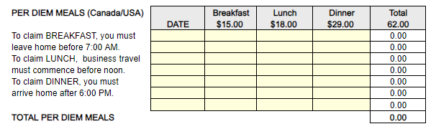

On the other hand, if you traveled outside Canada or the US, use the international per diem meals Table:
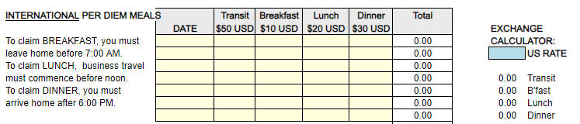

To do so, fill the exchange rate calculator with the CAD/USD rate of exchange (at the time you traveled) and use the amounts for each type of meal to fill the Table.

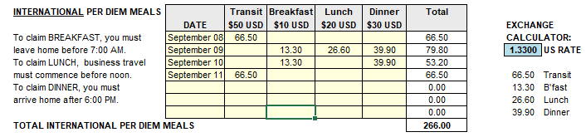

Most common reasons why claims are returned
  - Some receipts are missing. You have to provide receipts for every category for which you submitted a reimbursement request: accommodation / airfare / ferry/ ground transportation (Taxis, bus) and registration fees.
  - Receipts don’t have your name or the date (for accommodation, airfares and registration receipts)
  - Wrong currency: all budget items should be in Canadian dollars

Allowing enough time for “the process”
Once you send your claim to the CCFA office, this is then being reviewed and completed with the right cost center before being sent to the College Finance Department for final and payment by direct deposit. Some times are much busier than other and we thank you for your patience. If you have not received your payment 10 business days after sending you claim, please contact the CCFA office.

