Applying for Professional Development Funding

Submission Guidelines– January 2023

Submission Format
- Applications should submitted as a single PDF document named as: LAST NAME_First name
- Use the appropriate Excel form for your PD activity available on our website: PD Forms
- Convert the Excel form into a PDF document (do not forget to convert each sheet, there are 2 or 3 tabs in each Excel form). Refer to the ‘’How to submit a PDF application’’ document below
- Use the checklist at the top of the application forms
- Chair and Dean Approvals: should be now be done by email. Once you received the approval from your Chair and Dean, add the emails to the final PDF document.
- Email your application to fordp@camosun.ca and toffolettol@camosun.ca

Deadline
Applications must be received by CCFA by noon the Monday before the PD meeting (biweekly Tuesdays-see website calendar for specific dates), no exception.

Most common reasons why PD applications are returned
  - Not submitted as a single PDF document
  - Lack of supporting documents (especially conference and activity schedules) – this can be added as a link in the rationale section of your application
  - Insufficient rationale (all 3 questions have to be completed on Page 2)
  - Missing Chair and Dean approvals emails
  - Wrong currency: all budget items should be in Canadian dollars

Allowing enough time for “the process”
The PD committee requires your completed PD application 1 month in advance of travel within North America and 6 weeks in advance of International travel, when allowed. For exceptions, a detailed explanation must be provided.

For further details
Please refer to the PD Guidelines for current PD information.

PD Submission as One PDF Document

- Fill the appropriate form from the CCFA website: http://camosunfaculty.ca/professional-development/pd-forms/

- Complete all the Excel tabs (2 or 3 depending on the form) from the file

- Convert your Excel PD form application into one PDF document. Make sure that all excel pages are converted (select ‘’Add All’’ in the Acrobat PDFMaker prompt).
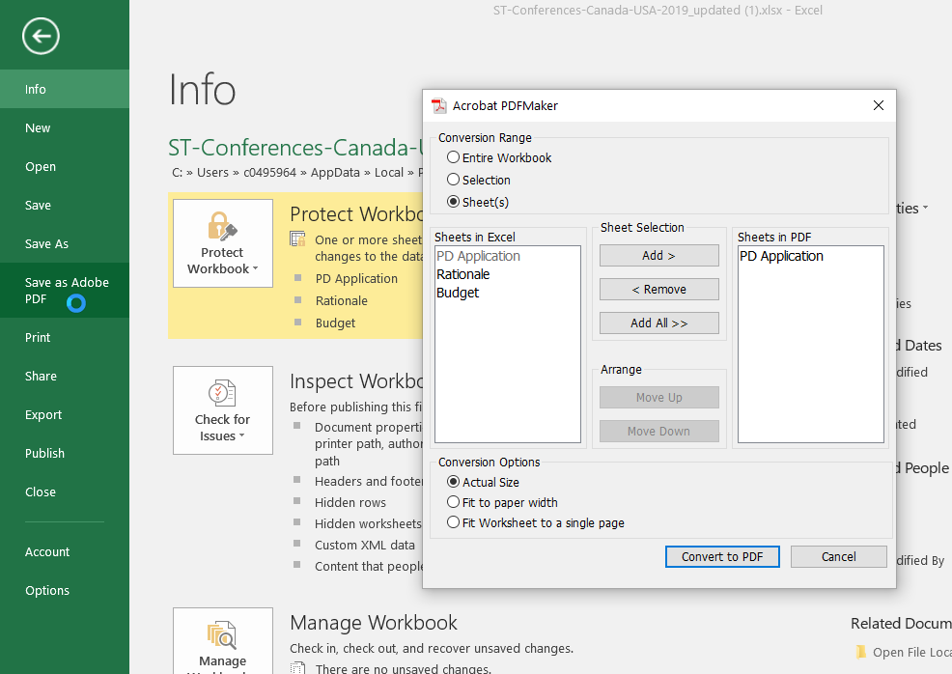
The prompter will only automatically select the excel tab where you were so you have to make not to skip this step and click on ‘’Add All’’.

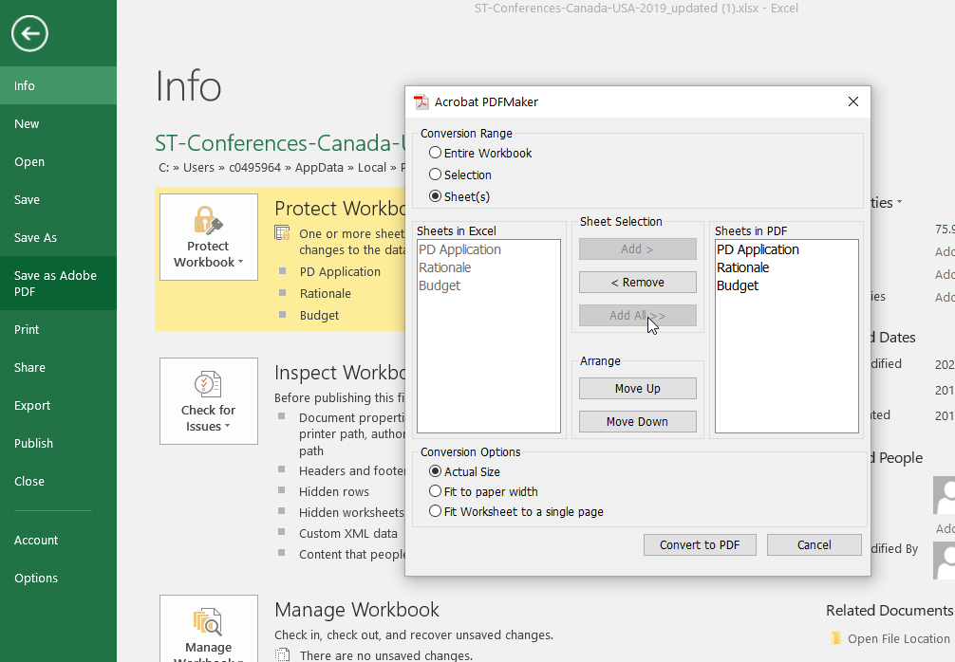

All tabs are selected and will be converted in pdf

Click Yes

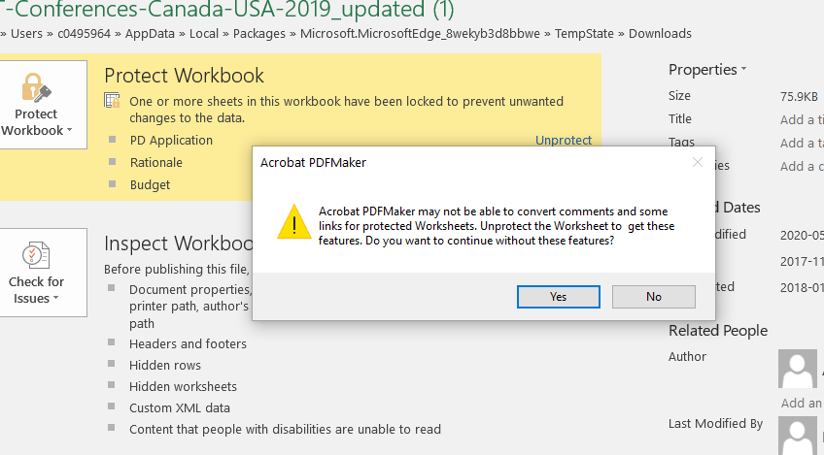

Then save the document on your computer.

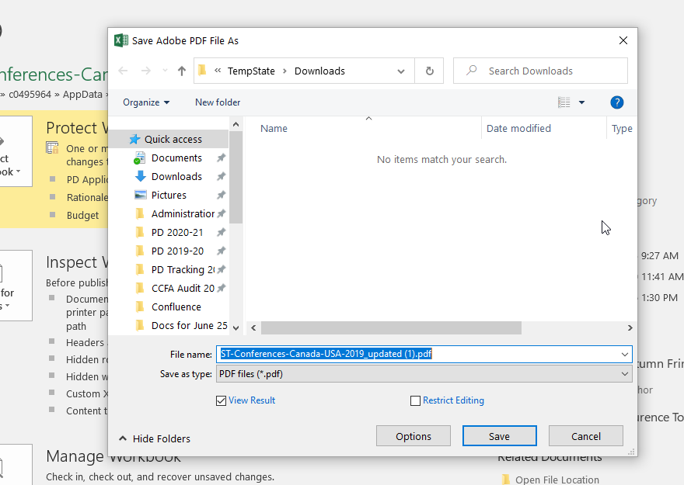

- Once you have your application form as a PDF document, you will have to add all other supporting documentations and email approvals (Chair and Dean).
These documents will have to be saved as PDF before being added to your application.

How to save an email as a PDF?

Double click on the email in your inbox and a window will open with only the email:
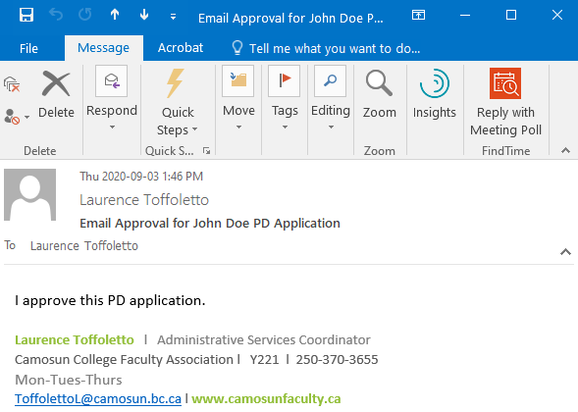
Click on ‘’File’’, then ‘’Save as Adobe PDF’’
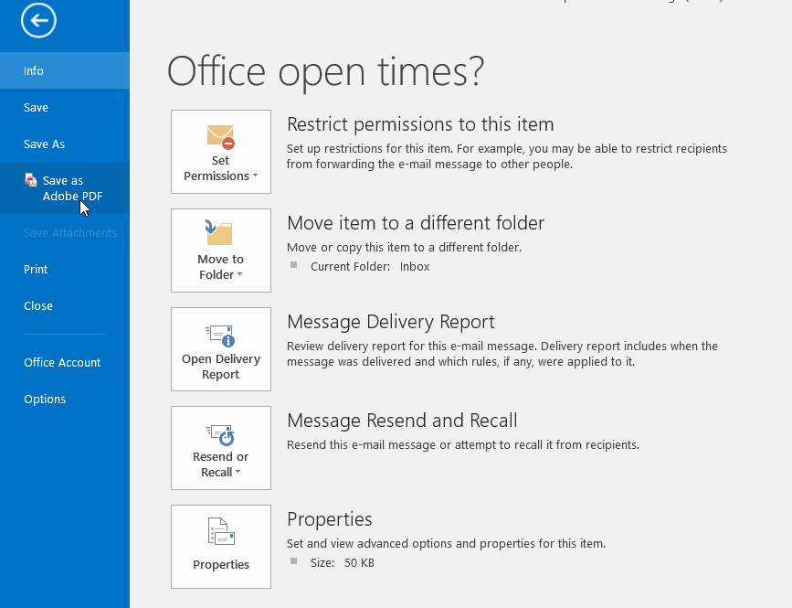

Save at the desired location on your computer.
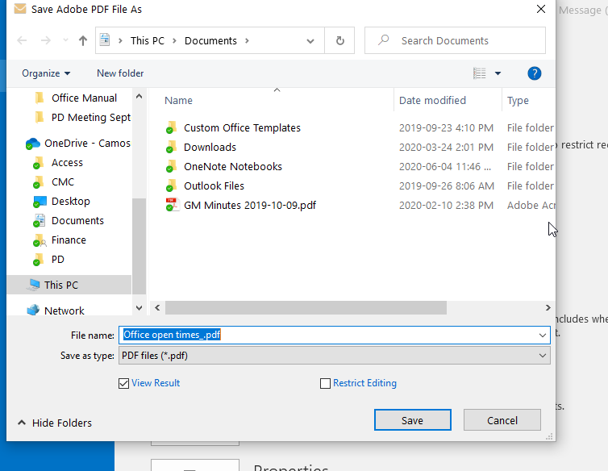

How to add PDF documents to your PDF application form?

- Open your PDF application and go to ‘’TOOLS’’,
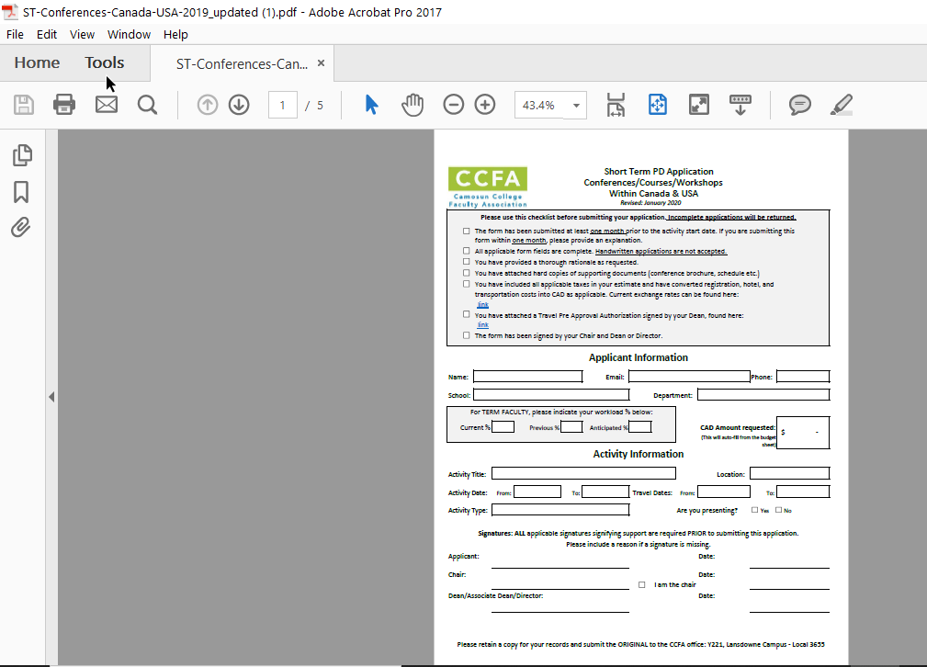
- Go to ‘’ORGANIZE PAGES’’
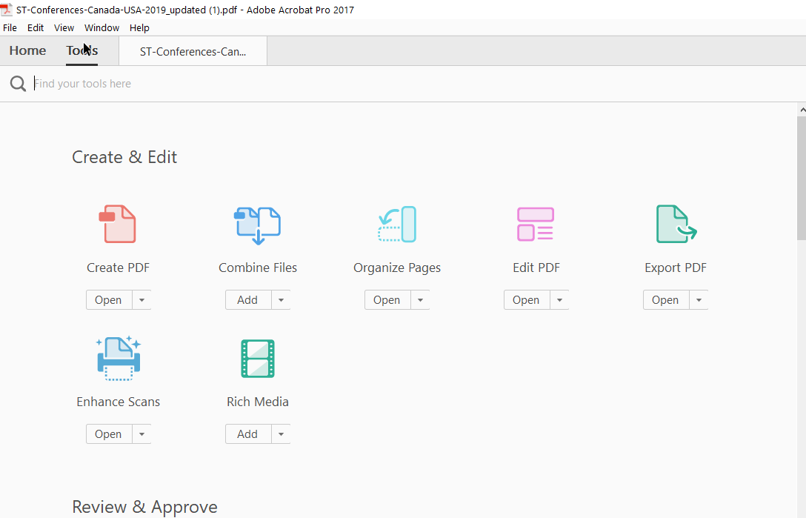

- Go to ‘’Insert’’, and select ‘’From File’’
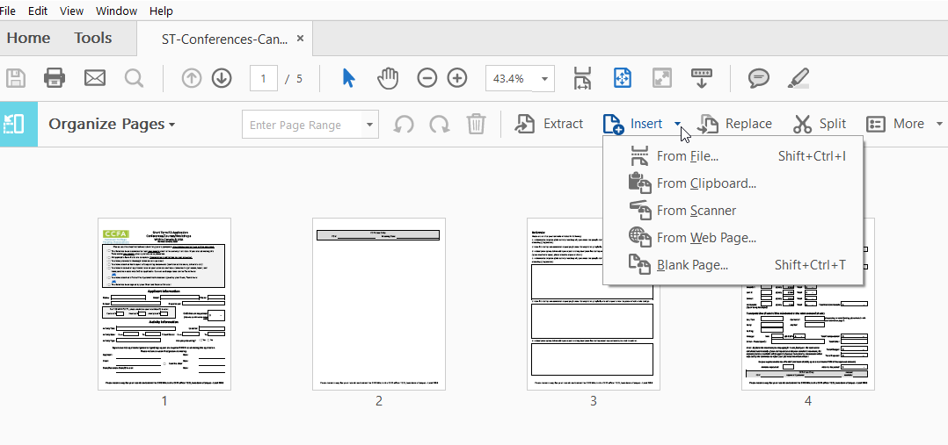

- Select the file(s) you want to add to your form (the signature email or supporting documentation for example).
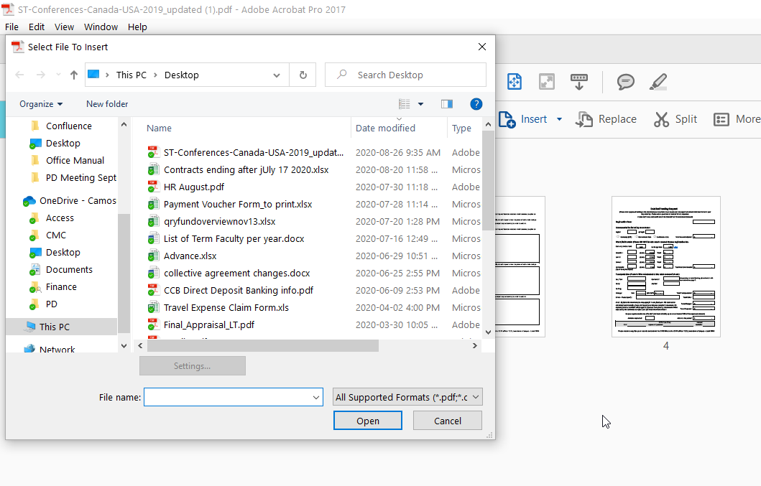
You now have your application form with your email approvals and supporting documentations if needed. Save this document as ‘’LAST NAME_First Name’’ and send it to the CCFA Office.
